
Assessed Coursework
Course Name | Systems Programming H
Coursework Number | 2
Deadline | Time: | 4:30pm | Date: | 25th November 2021
% Contribution to final course mark | 8%
Solo or Group ✓ | Solo | ✓ | Group
Anticipated Hours | 12
Submission Instructions
  As Specified in Section 4 below.
Please Note: This Coursework cannot be Re-Done

Code of Assessment Rules for Coursework Submission
Deadlines for the submission of coursework which is to be formally assessed will be published in course documentation, and work which is submitted later than the deadline will be subject to penalty as set out below.
The primary grade and secondary band awarded for coursework which is submitted after the published deadline will be calculated as follows:
- in respect of work submitted not more than five working days after the deadline
  - the work will be assessed in the usual way;
  - the primary grade and secondary band so determined will then be reduced by two secondary bands for each working day (or part of a working day) the work was submitted late.
- work submitted more than five working days after the deadline will be awarded Grade H.
Penalties for late submission of coursework will not be imposed if good cause is established for the late submission. You should submit documents supporting good cause via MyCampus.
Penalty for non-adherence to Submission Instructions is 2 bands
You must complete an “Own Work” form https://studentltc.dcs.gla.ac.uk/
for all coursework

Concurrent Dependency Discoverer

Requirement
Large-scale systems developed in C and C++ tend to include a large number of .h files, both of a system variety (enclosed in < >) and non-system (enclosed in “ ”). The make utility and Makefiles are a convenient way to record dependencies between source files, and to minimize the amount of work that is done when the system needs to be rebuilt. Of course, the work will only be minimized if the Makefile exactly captures the dependencies between source and object files.
Some systems are extremely large, and it is difficult to keep the dependencies in the Makefile correct as many people make changes at the same time. Therefore, there is a need for a program that can crawl over source files, noting any #include directives, and recurse through files specified in #include directives, and finally generate the correct dependency specifications.
#include directives for system files (enclosed in < >) are normally NOT specified in dependencies. Therefore, our system will focus on generating dependencies between source files and non-system #include directives (enclosed in “ ”).
For very large software systems, a singly-threaded application to crawl the source files may take a very long time. The purpose of this assessed exercise is to develop a concurrent include file crawler in C++.

Specification
You are to create a C++17 program dependencyDiscoverer.cpp based on the sequential template found on Moodle. The main() function must understand the following arguments:
-Idir indicates a directory to be searched for any include files encountered
file.ext source file to be scanned for #include directives; ext must be c, y, or l
The usage string is: ./dependencyDiscoverer [-Idir] file1.ext [file2.ext …]
The application uses the following environment variables when it runs:
CRAWLER_THREADS – if this is defined, it specifies the number of worker threads that the application must create; if it is not defined, then two (2) worker threads should be created.
CPATH – if this is defined, it contains a list of directories separated by ‘:’; these directories are to be searched for files specified in #include directives; if it is not defined, then no additional directories are searched beyond the current directory and any specified by –Idir flags.
For example, if CPATH is “/home/user/include:/usr/local/group/include” and if “-Ikernel” is specified on the command line, then when processing
#include “x.h”
x.h will be located by searching for the following files in the following order:
./x.h
kernel/x.h
/home/user/include/x.h
/usr/local/group/include/x.h

Design and Implementation

The key data structures, data flows, and threads in the concurrent version are shown in the figure below. This is a common master/worker concurrency pattern. The main thread (master) places file names to be processed in the work queue. Worker threads select a file name from the work queue, scan the file to discover dependencies, add these dependencies to the result Hash Map and, if new, to the work queue.

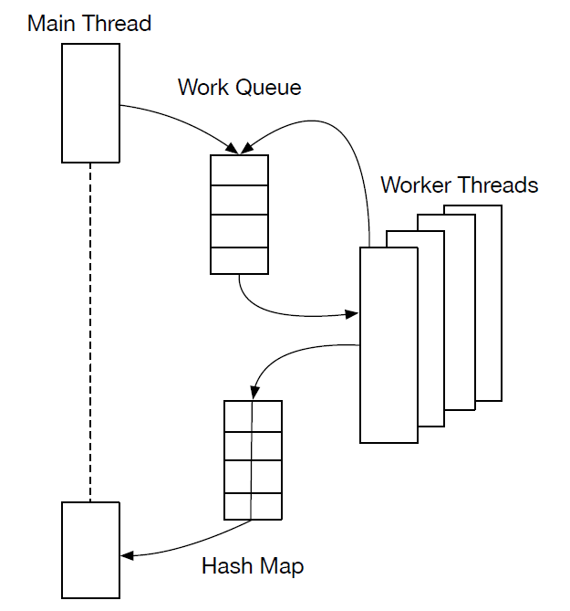

It should be possible to adjust the number of worker threads that process the accumulated work queue in order to speed up the processing. Since the Work Queue and the Hash Map are shared between threads, you will need to use concurrency control mechanisms to implement thread safe access.

How to proceed
You are provided with a working, sequential C++ 17 program called dependencyDiscoverer. Read the extensive comments in dependencyDiscoverer.cpp that explain the design of the application. Use the documentation at en.cppreference.com to check you understand how the C++ standard containers are used in dependencyDiscoverer.cpp.

Build the program with the provided Makefile and you can then test it by running
% cd test
% ../dependencyDiscoverer *.y *.l *.c
This should produce an output identical to the provided output file, so that the following
command should yield no output when the correct output is produced:
% ../dependencyDiscoverer *.y *.l *.c | diff - output

Start to make the code concurrent by creating new thread-safe Work Queue and Hash Map data structures that encapsulate the existing C++ standard containers. Create a struct that stores the container as a member alongside the synchronization utilities and provides a similar interface to the container, but with appropriate synchronization.

Once you have thread safe data structures, create a single thread to operate on them. Test the resulting program and keep a working copy in case the next stage goes wrong.

Once the single threaded version works correctly it should be straightforward to obtain the number of worker threads that should be created from the CRAWLER_THREADS environment variable and create that many worker threads. A key technical challenge is to design a solution so that the main thread can determine that all the worker threads have finished (without busy waiting) so it can harvest the information in the Hash Map.

Submission Options
As with assessed exercise 1, you have the option of submitting a less than complete implementation of this exercise. Your options are as follows:
- You may submit a sequential implementation of the Crawler; it must use thread-safe data structures. If you select this option, you are constrained to 50% of the total marks.
- You may submit an implementation which supports a single worker thread in addition to the main/manager thread. If you select this option, you are constrained to 75% of the total marks.
- You may submit an implementation that completely conforms to the full specification in Section 2 above. If you select this option, you have access to 100% of the total marks.
The marking scheme is appended to this document.

Submission
You will submit your solutions electronically by submitting the following files on Aropa2: http://aropa2.gla.ac.uk/aropa/
- dependencyDiscoverer.cpp – the source file as described above
- report.pdf – a report in PDF as specified below.
Your source file must start with an “authorship statement” as follows:
- state your Aropa login ID, and the title of the assignment (SP Exercise 2)
- state either “This is my own work as defined in the Academic Ethics agreement I have signed.” or “This is my own work except that …”, as appropriate.
You must complete an “Own Work” form via https://studentltc.dcs.gla.ac.uk/.
Assignments will be checked for collusion; better to turn in an incomplete solution that is your own than a copy of someone else’s work. There are very good tools for detecting software plagiarism, e.g. JPLAG or MOSS.
Do not
- upload your code to a public repository, like github, as fellow students may copy it, or
- use code from a public repository.
In either case you may find yourself in a plagiarism investigation.

Report Contents
Your report should contain the following Sections.
- Status. A brief report outlining the state of your solution, and indicating which of the single threaded, two threaded or multithreaded solutions you have provided. It is important that the report is accurate. For example, it is offensive to report that everything works when it won’t even compile.
- Build, and sequential & 1-thread runtimes. A screenshot showing
(a) The path where you are executing the program (i.e. pwd)
(b) your crawler being compiled either manually by a sequence of commands, or by a Makefile
(c) the time to run your sequential crawler on all .c, .l and .y files in the test directory.
(d) the time to run your threaded crawler (if you have one) with one thread.
You’ll need to use time to obtain understandable times, and to pipe the output to a file to keep the screenshot manageable, e.g.
bash-4.2$ time ./dependencyDiscoverer -Itest test/*.c test/*.l test/*.y > temp
real 0m0.030s
user 0m0.007s
sys 0m0.017s
bash-4.2$

- Runtime with Multiple Threads.
3a Screenshot. A screenshot showing the path where you are executing the program (i.e. pwd), and the times to run the crawler with 1, 2, 3, 4, 6, and 8 threads on all .c, .l and .y files in the test directory.
3b. Experiment with your multithreaded program, completing the following table of elapsed times for 3 executions with different numbers of threads on one of the School stlinux servers. Compute the median elapsed time. To get reproducible results you should run on a lightly loaded machine.
3c. Discussion. Briefly describe what you conclude from your experiment about (a) the benefits of additional cores for this input data (b) the variability of elapsed times.

CRAWLER_  THREADS | 1 | 2 | 3 | 4 | 6 | 8
CRAWLER_  THREADS | Elapsed Time | Elapsed Time | Elapsed Time | Elapsed Time | Elapsed Time | Elapsed Time
Execution 1
Execution 2
Execution 3
Median

Marking Scheme

Your submission will be marked on a 100 point scale. There is substantial emphasis on WORKING submissions, and you will note that a large fraction of the points is reserved for this aspect. It is to your advantage to ensure that whatever you submit compiles, links, and runs correctly.

You must be sure that your code works correctly with clang++ on the School stlinux servers, regardless of which platform you use for development and testing. Leave enough time in your development to fully test on the servers before submission.

Points | Description
10 | Your report – accurately, clearly and honestly describes the state of your submission
90 | dependencyDiscoverer (+ other classes, if provided)  workable solution (looks like it should work):  16 marks if sequential  25 marks if 1-worker thread  40 marks if multiple workers  4 for successful compilation with no warnings  10 appropriate thread safety implemented for Working Queue and Hash  Map  10 efficient mechanism for determining when worker threads have  finished: 0 if sequential  8 if it works correctly with the files in the test folder and an unseen folder  of files  8 runtime performance with 1 worker on test folder is shown to be similar  to single threaded implementation: 0 if sequential  10 sound experimentation with different numbers of threads, and analysis of  the results: 0 if sequential or 1-worker thread.

Some things should be noted about the marking schemes:
- If your solution does not look workable, then the marks associated with successful compilation and lack of compilation errors are not available to you.
- The marks associated with “workable solution” are the maximum number of marks that can be awarded. If only part of the solution looks workable, then you will be awarded a portion of the points in that category.

